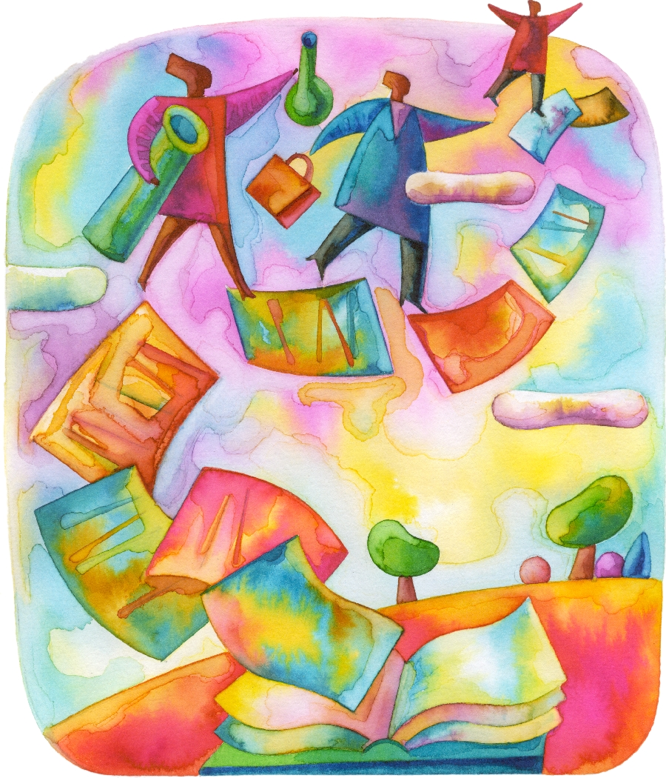
Franklin University
Faculty Workshops Presented in 2006-2007

Solving the Grading Rubric “Cube”
Giving Constructive Feedback
Using Course Evaluations to Improve Teaching
Sharing Your Story: Highlights of the life of an Adjunct Professor
Credible Resources in Research
The Philosophy of Learning
What does the (University Department) have to offer?
Rights and Responsibilities of the Disabled Student
Effective On-Line Communication
Use of Instructional Gaming
The Art of Teaching
APA and Addressing Plagiarism
The Dark Side of Teams
Increasing Written Feedback Effectiveness
Critical Factors to Successful On-Line Teaching
Technology in the Classroom
Managing an On-Line Course
Everything You want to Know about Accreditation
The New Lexis Nexis Academic
Giving Constructive Feedback
Using Humor in the Classroom
Do you Teach the Way They Learn
Helping Students Use Creativity in Their Assignments
What’s a Wiki?
Adult Learning
Educating the .Net Generation
Help! I am downing…
Productive Solutions to Persistent Problems
Working with ESL Students
Is This Bulletin Board Worth Any Points?
Difficult Students in the Classroom
There’s More to Research Than Googling
The Art of Changing the Brain

